Enumerator Reference Sheet

General tips & reminders

- Eligibility - Respondent must be knowledgeable on income sources and food consumption patterns of the household as a whole. Respondents should be over 18 years old. Consent to participate to the household data collection
- Refer to the entire of household unless otherwise indicated as individual
- Pay attention to the reference period! questions refer to the period in the last 7 days, 30 days, 6 months, 12 months
Always mention the recall period. Some reference periods:​
Question​ | Reference period​
Food Consumption | Last 7 days
consumption coping strategies​ (rCSI) | Last 7 days​
Income | Last 30 days​ and 12 months
Expenditure | Last 7 days, Last 30 days and last 6 months
Livelihood coping strategies(LHCSI) | Last 30 days​
- questions contain “Don’t know” and “Refused”. Avoid “Don’t know” responses as much as possible! Probe.
- “Other (specify)” should not be used if the answer option is already in the answer list. Text should be written in Myanmar language
- Do not read out answer options unless otherwise indicated (few questions)
- Lists of answer options are exhaustive and mutually exclusive for most core questions.
  - This means all possible answers provided by a respondent should fit within one and only one category provided in the list of answer options
- Most lists of answer option are for your use only. Let the respondent answer spontaneously and you choose the category that best fits the response. If there is any doubt: probe.

- if you wish to contact WFP for any question, you can do so by calling us at…………………………………………..

FOOD CONSUMPTION
Enumerator information
Intro Notes: reference period – last 7 days / most members of your household (50% +) eat / do not count small quantities
Please ask/read all the questions without skipping any parts.​
For all food items, the recall period is set at the previous seven days.
Number of days eaten in past 7 days requires a numeric value (0 – 7)
Ask respondents how many days (within the past week) their household consumed each of the food items/groups listed in the module and the respondent must answer on behalf of the entire household
If one member of a household consumes food away from the household, the items eaten should not be recorded.
Similarly, if a food item is consumed at home by only one household member it should not be recorded.
If the entire household ate outside of the household, then the foods consumed should be recorded.
Listed food items/groups are mutually exclusive. Be careful not to record consumption of any one food item in more than one category in the list.

Small quantities
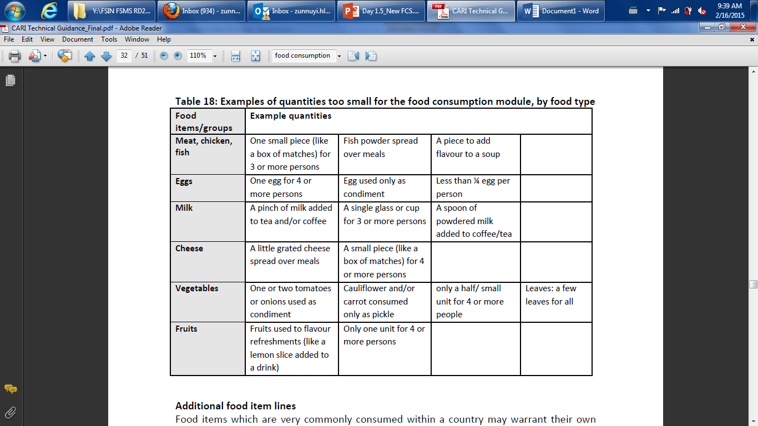

Coping strategies index (CSI)
“What do you do when you don’t have enough food, and don’t have enough money to buy food?”
Consumption Coping Strategy(rCSI)
reference period – last 7 days

Livelihood Coping Strategy (LHCSI)
reference period – last 30 days
four options
Coping Stratagy Yes (or) No Question
1 = No, because I did not need to
2 = No, because I already sold those assets or have engaged in this activity within the last 12 months and cannot continue to do it
3= Yes
4= Not applicable (don’t have children/ these assets)

Foods Needs / Essential Needs
Food Needs /Essential Needs/Non-Food

Income and Expenditure
à You are asking the income of the entire household
- If there are more than one household earner, make sure all income sources are considered
- Definition: An income earner is someone who earns money or produces profit.
Income sources
Do not read out the answer options
This question refers only to money! There should be no mention of in-kind donations from friends/family.
Proceeding by elimination (by exclusion) you should find the category that best fits.
You should never have to choose “Other” = The options are exhaustive.
If “don’t know” or you do not understand the response à probe

“We had no income at all”
  - PROBE to check if charity was received [check answer options]
  - If not, PROBE to understand whether they have mainly used debt or savings over the past 30 days. These two answer options [ used debt or saving] should only be used if there is no other income source.

Expenditures
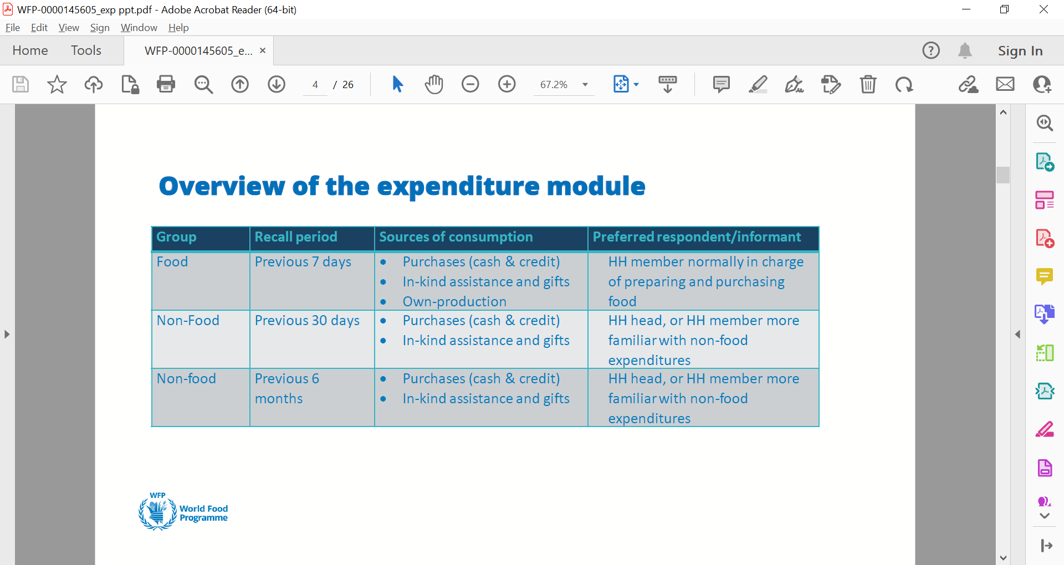
- Here we would like to know an estimate of the total household expenditures in the previous 30 days (Food and non-food items)/ 6 months for some of non-food items.
- Total household expenditures include food, education, hygiene, housing and bills, transport, …
- You can help the households by reminding them the different categories of expenditures
- If the household incurred in big one-off expenditures (durable products, such as a house, furniture, and equipment) these should not be included in the monthly expenditures
- Probe if the answer seems too extreme (too low or too high)
Did your household purchase any [item] in the last 30 days?  If yes, please estimate the total amount spent in cash and/or credit. |  |  | In the last 30 days, did your household consume any [item] that came from in-kind gifts and/or assistance?  If yes, please estimate the value from in-kind assistance or gift.  If no consumption, please put 0 | In the last 30 days, did your household consume any [item] that you produced, gathered or received in exchange of labor?  If yes, estimate the value of [item] you produced, gathered, hunted or received in exchange of labour.  If no consumption put 0
1=Yes ->  0=No -> next question (Assistance) | Cash  (MMK) | Credit  (MMK) | Gift/assistance (MMK) | Own production (MMK)
_Purch | _MN | _CRD | _GiftAid | _Own

The Structure of the Questionnaire
Technical
GPS Point (Offline)
HHID (Long Questions and Short Questions)
Section A. Demographic

Residence status
Permanent resident | Permanent resident: Someone who was either born in the town/village of residence or moved there more than two years ago voluntarily (for work or family reasons or other reasons not forced by conflict or natural disasters). Permanent residents may be former IDPs if they chose to stay in their current place of residence voluntarily and do not intend to go back to their former home.
Returnee | Returnee: A person who was displaced from their habitual residence either within their country (former IDP) or abroad (former refugee), who has since voluntarily chosen to return (independently or with the help of other actors) to their habitual residence. A person may be a returnee for up to 2 years (24 months).
Internally displaced persons (IDP) | IDP: A person forced or obliged to leave their homes or places of habitual residence, because of or to avoid the effects of violence or natural disasters, and who have not crossed a recognized international border. There is no time limit on being an IDP. This status ends when the person is able and willing to return to their original home or makes a free choice to settle in a new location.

Household
Household | A household is a person or a group of persons who eat from the same pot and share resources and are normally living together at least 4 nights weekly and have only one person whom they all regard as the head of household. – do not include those who have migrated.  Remember:  •A member does not have to be related to other household members by blood or marriage.  Make clear that questions refer to the group of people in the household, not just the respondent  • Make sure to include the head of the household, elderly & babies [sometimes unintentionally forgotten/left out]
head of household | A member of the household that is acknowledged as head by other members because of his/her age or standing in the household as the chief income earner; or, takes major decisions, including about the household budget.  Remember:  - The head has primary authority & responsibility for household affairs.  - In countries where short labour migration (< 6 months) is common, the head may be the person who is away.

Section B. Health | Section B

Disable
Disabilities | Note: to count as a disability the person must have a lot of difficulty or cannot do at all, any of the following: seeing (even if wearing glasses), hearing (even if wearing hearing aids), walking or climbing steps, remembering, or concentrating, self-care (such as washing or dressing) or communicating (understanding or being understood).

Section: English | Spanish Translation
Section C. Perception of food insecurity | Section C.
Section D. Household Hunger Scale (HHS) | Section D.
Section E. Combined (FCS/FCSN) | Section E
Section E. Food Consumption Score | Section E.
Section F. Reduced Coping Strategies (rCSI - Gendered) | Section F. (rCSI - Gendered)
Section G. Livelihood Coping Strategies (LCS-EN) | Section G. (LCS-EN)
Livelihood Coping Strategies (FS)
Section H. Expenditures | Section H.
Food
Non-Food (Consumption)
Non-Food (Intermediate)
Expenditures
Food
Non-Food (Consumption)
Non-Food (Intermediate)
Section I. Assistance: Entitlement, Utilization & Preference | Section I.
Assistance (ENA) | (ENA)
Section J. Income | Section J.
Income
Section K. Food Insecurity Experience Scale | Section K.
Food Insecurity Experience Scale
Section L. Housing | Section L.
House (Basic)
Water (Sources)
Section M. Household assets | Section M.
Simple Household Items
Basic Electric Items
Advanced Electric Items
Transport Assets
Livestock Assets
Livelihoods Assets
Section N. Safety | Section N.
Safety (Basic)
Section O. Minimum Dietary Diversity | Section O.

Purchases made cash include purchases made on cash assistance as well as purchases made on value vouchers (value paper voucher, value e-voucher). Commodities consumed on commodity voucher (commodity paper voucher, commidity e-voucher) should be counted in the colomn in-kind assistance.
This caterogy includes the following sources: In-kind assistance from international and local NGOs, government, UN Agencies; gifts from family and friends; borrowing from family and friends; begging
Credit refers to the purchases that have been made by credit and not been repaid in the reference period. Definition of credit needs to be contextualized, to ensure it does not capture usual behaviour with regular repayment, but behaviour that can lead to overindebtedness.

